Nomenclature – Hydrocarbons and Haloalkanes (alkyl halides)

1. Alkanes
- Draw the structures for the following compounds:
  - 2-methylpropane
  - 2,3-dimethylpentane
  - 3-ethyl-2,4-dimethylhexane
- Name the following compounds, all of which have the molecular formula C₆H₁₄:
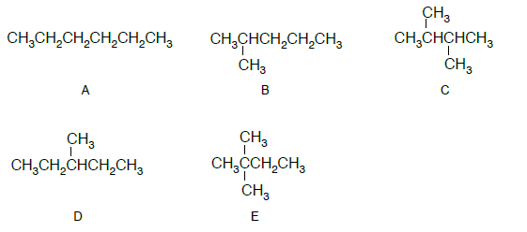

2. Cycloalkanes
- Draw the structures for the following compounds:
  - cyclobutane
  - cyclopentane
  - 1,3-dimethylcyclohexane
- Name these compounds:
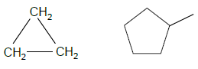

3. Alkenes and Alkynes
- Draw the structures for the following compounds:
  - but-2-ene
  - 2,3-dimethylbut-2-ene
  - 3-ethyl-4-methylpent-1-yne
- What is incorrect with the name 2-methylbut-2-yne?
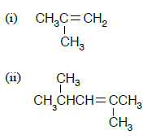
- Name these compounds:

4. Compounds containing halogens
- Draw the structures for the following compounds:
  - tetrachloromethane
  - 1,1-dichloroethene
  - 1,2-dibromo-2-methylbutane
  - 1,2-dibromocyclohexane
- Name these compounds:
